Phaser Client User Guide

Version 1.1

Revision History 2

Overview 3

Launching 3

Main Window 3

Job Configuration 3

Server Status 3

Commands 4

New Job 4

Cavity Selection Panel 4

Moving Cavities 4

Ordering Cavities 5

Option Selection Panel 5

Results 5

Results Tab 6

Jobs Tab 7

System Administration 7

Source Code 7

Installation 8

Configuration 8

Documentation 8

Figures 9

Figure 1: Main Window 9

Figure 2: New Job Dialog 10

Figure 3: Batch Select Dialog 11

Figure 4: Results Dialog 12

# Revision History

|  |  |  |  |
| --- | --- | --- | --- |
| **Date** | **Version** | **Description** | **Author** |
| 2014-Jun-17 | 0.4 | Initial guide | Ryan Slominski |
| 2016-Mar-18 | 0.14 | Updated to match protocol document 1.17 and Requirements document 3.1 | Ryan Slominski |
| 2016-Mar-28 | 0.16 | Updated to match protocol document 1.18 | Ryan Slominski |
| 2016-Apr-05 | 1.0 | Updated per cjs comments | Ryan Slominski |
| 2018-Apr-11 | 1.1 | Document cavity name and last phase correction sorting in new job dialog available cavities selection. Also mention the export to elog button. | Ryan Slominski |

# Overview

The Phaser Client is a Java Swing application which allows Operators to monitor and control RF cavity phasing jobs and Scientists to review the phasing results. Multiple clients can run concurrently allowing Operators to seamlessly handle shift changes.

# Launching

The Phaser Client can be launched from JMenu by either using the search box with term “phaser” or by directly navigating the menus **Operations** -> **RF System** -> **Phaser**.

# Main Window

The main window shows the state of the phaser server, whether it be working on phasing cavities, idle, paused, or in an error wait state about to retry a problem cavity. There are three panels:

1. Job Configuration Information – Shows the current job configuration and progress (which cavity is being worked)
2. Server Status Information – Shows the status of the server and the progress of the current cavity (percent completed of current cavity)
3. Command buttons – Allows users to do launch a new job, pause, stop, resume, skip, and review results.

## Job Configuration

The main window contains a configuration panel which contains the following fields (See Figure 1):

* Cavities – The ordered set of cavities to phase. The current cavity under phase measurement is highlighted.
* Job # - The job identifier. Use this when searching the results for a particular job
* Job Start – The date and time when the job commenced
* Max Phase Error – The maximum phase angle error for the job (degrees)
* Max Momentum Error – The maximum momentum error (dp/p)
* Kick Samples – The number of samples per phase angle kick

See the server documentation for more details about the options.

## Server Status

The main window contains a status panel which contains the following fields (See Figure 1):

* Job State – One of IDLE, WORKING, PAUSED, ERROR
* Job Message – A message of the server’s choosing to add additional detail on the phasing job
* Cavity Progress – The percent complete of the current cavity (0-100) in the form of a progress bar. Generally, the current cavity name is displayed inside the bar or the word “Waiting” to indicate that the server is waiting for the machine to settle before continuing. This label is set by the server, however.
* Cavity Start Date – The start time of the current cavity

## Commands

The main window contains a commands panel which contains the following buttons (See Figure 1):

* New Job… – Opens the new job dialog
* Pause – Pause the phasing job if it is in the state WORKING
* Resume – Resume the phasing job if it was in the state PAUSED
* Stop – Stop and clear the phasing job if it was in the state WORKING or PAUSED
* Skip – Skips the current problem cavity (only available in ERROR WAIT state).
* Results… - Opens the results dialog
* Help… - Opens the help dialog

# New Job

The new job dialog contains a cavity selection panel and an option selection panel (See Figure 2).

## Cavity Selection Panel

The cavity selection panel enables users to specify which cavities should be phased and in what order. A pick list widget is provided and consists of a list of cavities which are available per the CED and a list of cavities which have been scheduled for inclusion in the job. Initially the scheduled list is empty and users must move cavities from the available list into the scheduled list. Groups of one or more cavities are appended to the end of the scheduled list with each move operation, and cavities within a group are sorted based on sort configuration on the available cavity list. Once cavities have been moved into the scheduled list they can be ordered however the user would like using ordering operations.

### Selecting Cavities

A cavity can be selected by clicking on it with the mouse. Multiple cavities can be selected by holding down the Ctrl key while clicking. A range of cavities can be selected by holding down the Shift key while clicking.

### Moving Cavities

There are three ways to move cavities between lists: Move All, Move Selection or Move Batch.

#### Move All

The easiest method is to move all cavities either into or out of the scheduled list. Click on the double right arrow button (Move All Right) to move all of the cavities from the available list into the scheduled list. Click on the double left arrow button (Move All Left) to move all of the cavities from the scheduled list back into the available list.

#### Move Selected

The most flexible method is to move only selected cavities. Once one or more cavities has been selected in the available list click on the single right arrow button (Move Selected Right) to move the selected cavities from the available list into the scheduled list. Use the single left arrow button (Move Selected Left) to move selected cavities from the scheduled list back into the available list.

#### Move Batch

The batch select feature is a method of moving cavities in batches defined by area (linac) or zone (cryomodule). Unlike the other two methods this method can only be used to move cavities into the scheduled list (not back). Clicking on the “Batch Select…” button opens the Batch Select dialog (See Figure 3). This dialog has checkboxes for users to select which areas or zones they would like to include in the job. Selecting both an area and all of the zones in the area is redundant and unnecessary, and will only result in one unique set of cavities added to the scheduled list.

### Sorting Cavities

The available list contains two columns: cavity name and last phase correction date, and is sorted using both columns. Initially the available list is sorted by last phase correction date in ascending order, and then by cavity name in alphabetical order (which also is s-coordinate order) ascending. This is to encourage users to phase cavities with the oldest last phase correction date first. Users can toggle which of the two columns is the primary (first) sort key by clicking on the column heading. The direction of the sort (ascending or descending) is also toggled by clicking on a column header. When moving cavities from the available list to the scheduled list the sort order you have set in the available table is maintained for the group of selected cavities. Each group of cavities moved to the scheduled table is appended to the end of the scheduled list so it is useful to move groups of cavities to the scheduled list in the order you intent to use to avoid having to manually modify the order in the scheduled list. The scheduled list is not sorted because it allows users to impose a custom arbitrary ordering using the UP and DOWN arrows.

### Ordering Cavities

The scheduled list has buttons running along the right side which allow ordering or a single cavity or an entire selection of cavities at once (recall multiple cavities can be selected by holding the Ctrl or Shift key while clicking). The double up arrow button (Move Selected to Top) moves the selected cavities to the top of the list. The double down arrow button (Move Selected to Bottom) moves the selected cavities to the bottom of the list. The single up arrow button (Move Selected Up One) moves the selected cavities up one position in the list. The single down arrow button (Move Selected Down One) moves the selected cavities down one position in the list.

## Option Selection Panel

The option selection panel allows specification of job options. The options are:

* Max Phase Error – The initial maximum phase angle error (degrees)
* Max Momentum Error – The initial maximum momentum error (dp/p)
* Kick Samples – The number of samples per phase angle kick

See the server documentation for more details about the options.

# Results

The results dialog contains a results tab and a jobs tab (See Figure 4). Each tab allows users to search the Phaser database; the first tab allows results searches and the second tab allows job searches. Searches can be filtered by various parameters and are paginated with a maximum of 500 records per page to avoid the performance implications of displaying too many results at once. Filters are applied by “and-ing” them together. Filters that are empty are ignored. When the results dialog opens it shows the results tab and displays the results of the most recent job by default. Pagination controls and index are hidden unless needed. If more than 500 results then there are Next and Previous buttons for navigating through the paginated results and the query filter and pagination status is displayed below the filter panel, and above the data table.

Each row of the results table represents a cavity measurement attempt, and possibly correction attempt. The Outcome field explains the state of the result. The valid values are:

* MEASURED – Server was able to successfully measure and record the phase angle error
* SKIPPED – Server was asked to skip this cavity (probably because it was retrying too much)
* BYPASSED – Server bypassed (skipped) this cavity because the control system has this cavity denoted as “bypassed”
* CORRECTED – Server was able to successfully apply phase angle error correction (implicitly means that it had been successfully measured)
* ERROR – Server was unable to apply phase angle error correction and has decided it will not allow future attempts to do so (error too large, measurement date too old, etc).
* DEFERRED – Server was unable to apply phase angle error correction and has decided it will allow future attempts (database was down so couldn’t record result, control system temporarily unavailable, etc).

## Results Tab

The results tab allows searching the results database. Each result record consists of the following fields:

* Cavity – The cavity name
* Phase Error – The phase angle error measured (and possibly applied – see OUTCOME)
* Outcome – One of CORRECTED, MEASURED, BYPASSED, ERROR, SKIPPED, DEFERRED
* Start Date – The date and time the phasing of the cavity began
* Duration (Seconds) – The duration of the cavity phasing, in seconds
* Corrected Date – The date the phase angle error corrections were applied (or attempted)
* Corrected Error Message – Describes any error encountered applying corrections (only if outcome is ERROR). Note: ERROR won’t occur when measuring as measuring retries indefinitely when problems are encountered – usually you’ll get a SKIPPED instead.

The results can be filtered by the following fields:

* Job # - Restricts the results to only those belonging to the specified job identifier
* Min Cavity Start Date – Restricts the results to only those with a start date after the specified date and time
* Max Cavity Start Date – Restricts the results to only those with a start date before the specified date and time
* Cavity – Restricts the results to only those with the specified cavity name. The percent symbol “%” may be used as a wildcard, allowing filtering by linac or zone as well (Example: “0L%” filters results to only injector; “0L03%” filters results to only zone 0L03).
* Min Phase Error – Restricts results to only those with a phase angle error over the specified value
* Outcome – Restricts the results to only those with the specified outcome

The results tab has two ways to export data. An export to Excel button allows users to obtain an Excel file of the full un-paginated, but filtered result set currently in the display. An export to eLog button allows users to post an elog of the full un-paginated, but filtered result set currently in the display.

The results table also allows users to select results by clicking the checkbox in the first column or using the “Select All” or “Select None” feature in the button menu in the first column heading. After selecting results the user can click the “Apply Corrections” button to have phase angle error corrections applied and the results table reloaded with the updates.

## Jobs Tab

The jobs tab allows searching the jobs database. Each job record consists of the following fields:

* Job # - The job identifier
* Start Date – The date and time the job began
* Duration (Minutes) – The duration of the job
* Max Phase Error (Degrees) – The initial maximum phase angle error
* Max Momentum Error (dp/p) – The initial maximum momentum error
* Kick Samples – The number of samples per phase angle kick
* # Results – A count of the number of results completed during the job execution

The jobs can be filtered by the following fields:

* Job # - Restricts the jobs to only those belonging to the specified job identifier (zero or one record)
* Min Job Start Date – Restricts the jobs to only those with a start date after the specified date and time
* Max Job Start Date – Restricts the jobs to only those with a start date before the specified date and time

# System Administration

## Source Code

The Java Phaser Swing Client application is named *phaser-swing-client* and is stored in the git repository on devl00. It can be accessed by members of the JLab accelerator group *epics* from an accelerator Linux machine with the command:

git clone ssh://devl00/usr/devsite/git/phaser-swing-client.git

To switch to a particular version jump to the version-tag with a command like:

git checkout Release0.14

List all tags (versions) with the command:

git tag

Return back to most recent / end of main integration branch:

git checkout master

## Installation

The Phaser Swing Client is distributed as an executable jar file plus its dependencies: configuration and libraries. It was developed as a certified product and Linux binaries can be found in the /cs/certified/apps/phaser file system path. It is accessible from JMenu.

An Apache Ant build file (build.xml) is used to compile and package the application. Set your working directory to the phaser directory that you obtained from git and execute the following command to build the distributable package:

ant dist

The phaser/dist directory contains everything you need to run. You can copy this directory to wherever you want it. The script named phaser-swing-client.sh can be used to launch the application (you may have to chmod +x *.sh). You can also use debug-phaser-swing-client.sh to have logging to the console enabled (edit config/debug-logging.properties to have it go to a file instead).

## Configuration

You can configure several client application properties in the configuration file located at phaser/dist/config/client.properites:

* server.host=devl05
* server.port=30704
* db.url=jdbc:oracle:thin:@dbd:1521:devldb01
* db.user=phaser_reader
* db.password=xyz123
* default.max-phase-error=10
* default.max-momentum-error=1e-3
* default.kick-samples=8
* docs.url=http://devweb/controls_web/certified/rfPhaser/

## Documentation

You can build the JavaDoc API docs with the following command:

ant doc

The generated JavaDoc will be in dist/Javadoc. The other documentation (User Guide, Client-Server Protocol API, Requirements) are located in the dist/doc directory.

# Figures

## Figure 1: Main Window

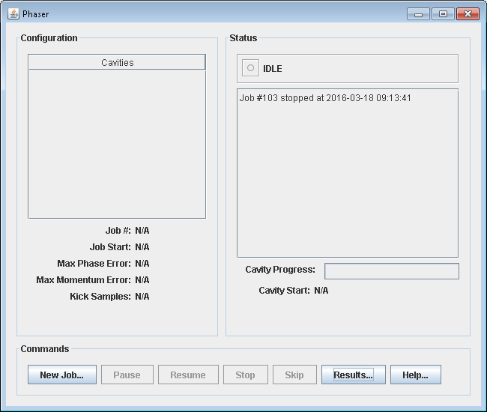

## Figure 2: New Job Dialog

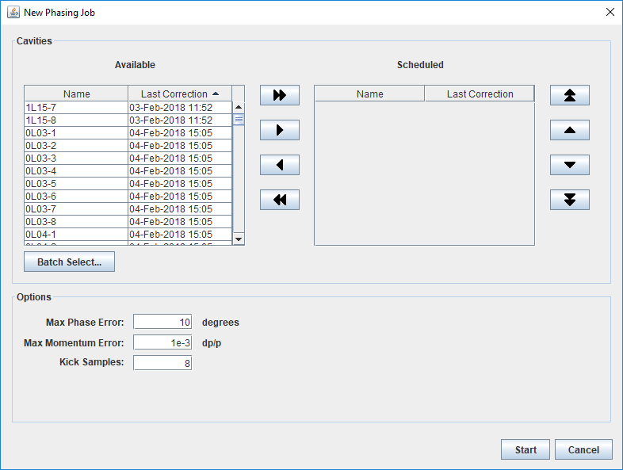

## Figure 3: Batch Select Dialog

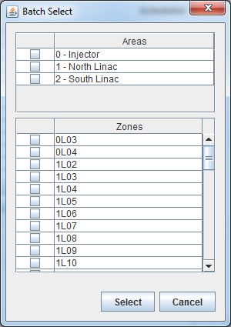

## Figure 4: Results Dialog

